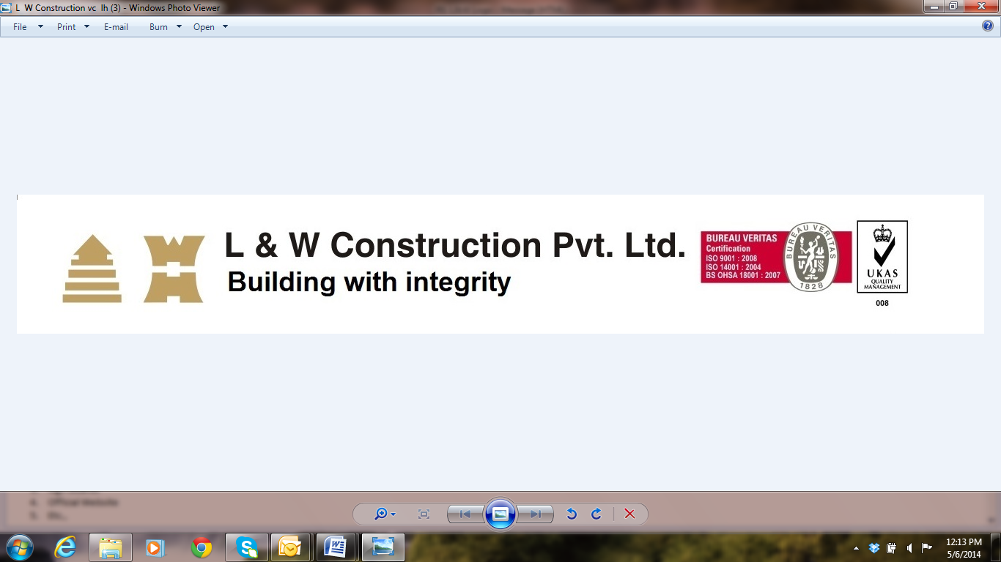 **Experience certificate**

**This is to certify that Mr.Serbin Ran had worked in safety coordinator in Mumbai. From 12-may -2015 to 24-april-2017 date as an HSE officer.**

**He has wide knowledge in Safety document control and site safety knowledge and having good exposure in safety side in Construction field.**

**He has performed his duties in a diligent and satisfactory manner and was a valuble member of capgemini Project HSE team.**

**We wish him success in his future endeavors.**